Computational Sciences Club presents


An introductory workshop on:

by
Ramachandran Subramanian

Learn how to make presentations, journal articles, posters and much much more ...

When: Friday, November 13th, 4:30 PM
Where: 206 Furnas
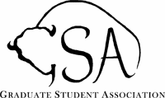
Event sponsored by: GSA

